Yes—there are **several “second-order” details** that don’t always show up on drawings but materially improve estimate accuracy, protect margin, and impress owners and GCs. These are the things senior estimators look for while junior ones are still counting ducts.

Below is the **next layer most estimates miss**.

**12. Design Intent & Performance Assumptions (Hidden Risk)**

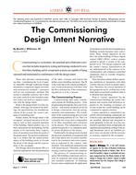

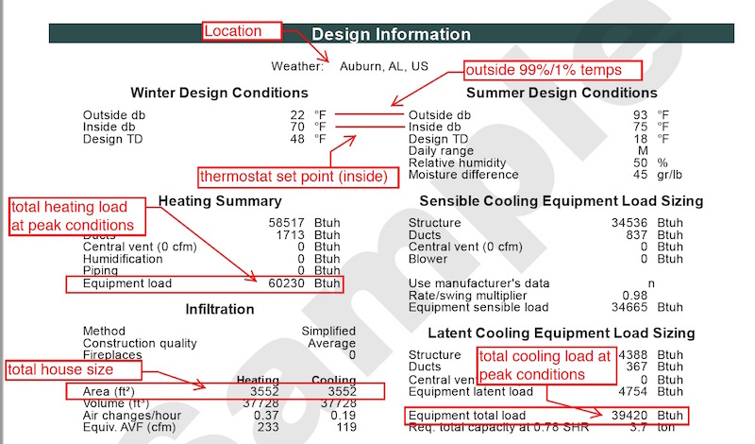

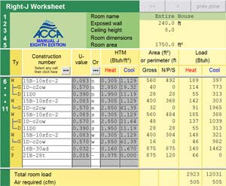

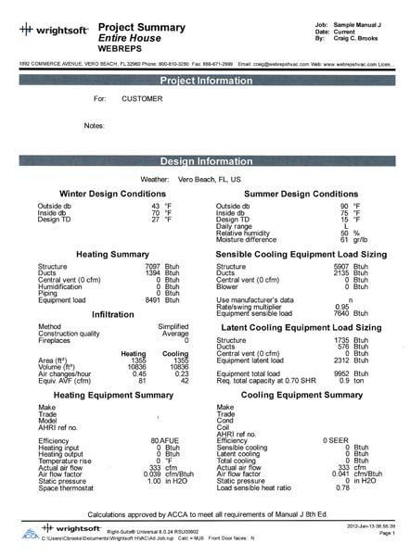

If available, capture:

* Design intent narrative
* Load calculation method (Manual J / N / ASHRAE)
* Target airflow (CFM per zone)
* Static pressure assumptions
* Redundancy or future expansion provisions

Why it matters:  
If airflow or static is undersized, **you own the fix**, not the engineer.

**13. Zoning & Comfort Strategy**

* Number of zones per system
* Priority zones (server rooms, labs, kitchens)
* Setback schedules
* Noise criteria (NC ratings)
* Air distribution strategy (mixing vs displacement)

Comfort complaints cost more than callbacks—because they never end.

**14. Installation Logistics (Often a Profit Killer)**

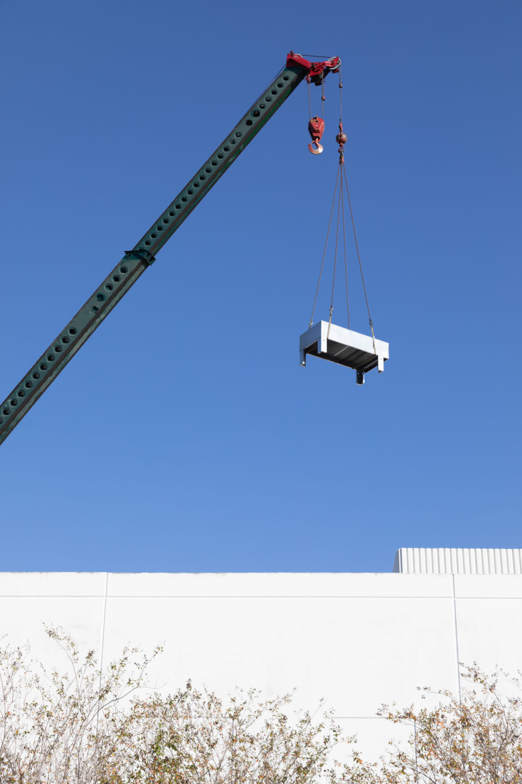

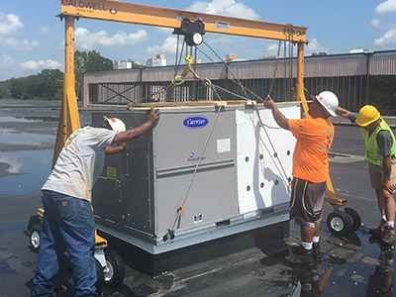

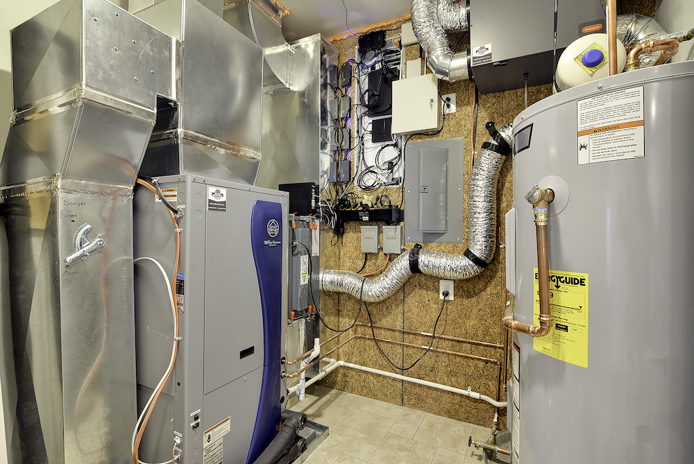

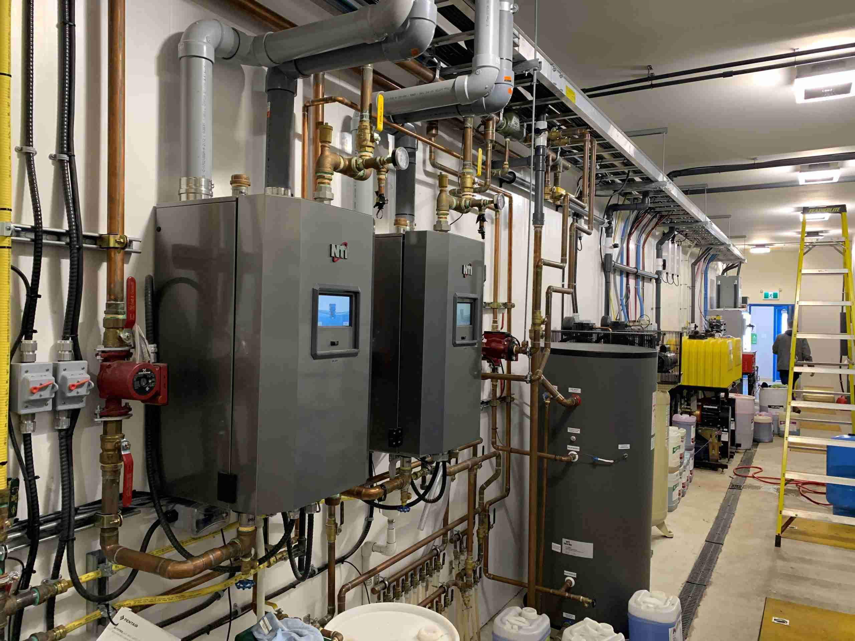

* Crane picks (quantity + duration)
* Street closures / permits
* Rigging complexity
* Roof reinforcement
* Equipment staging areas
* Temporary weather protection

One forgotten crane day can erase your margin. Ask how I know.

**15. Sequencing & Trade Coordination**

* When HVAC installs relative to framing
* Ceiling close-in dates
* Coordination with fire sprinkler heads
* Conflicts with lighting layouts
* Structural beam conflicts
* Shaft space constraints

Clashes don’t show up in takeoffs—but they show up in change orders (or losses).

**16. Manufacturer & Supply Chain Risk**

* Long-lead equipment (RTUs, VRF, VAVs)
* Approved alternates
* Escalation clauses
* Storage requirements
* Warranty start dates (delivery vs startup)

If lead times are 20+ weeks and you didn’t flag it, you become the delay.

**17. Commissioning & Owner Training (Often Ignored)**

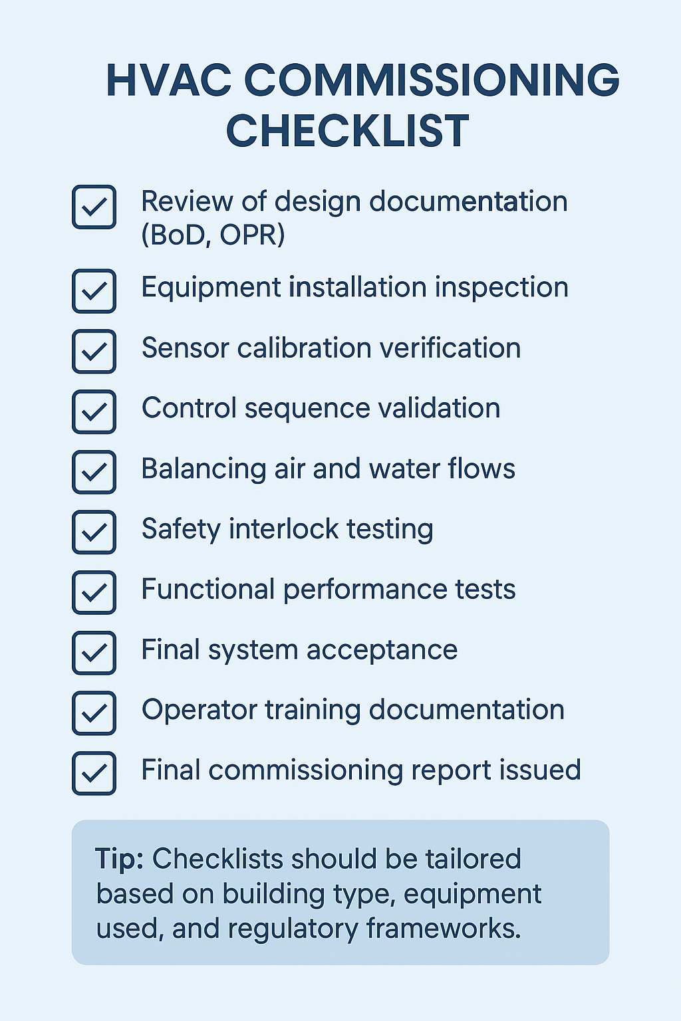

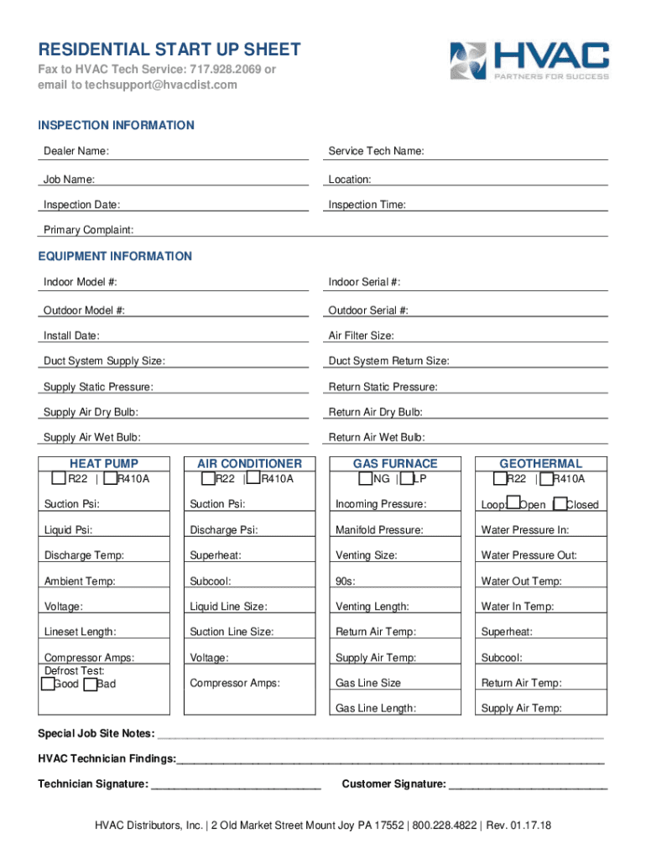

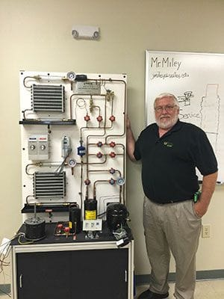



* Functional performance testing
* Owner training hours
* Seasonal commissioning
* TAB coordination responsibilities
* Re-test allowances

Commissioning is where “installed” becomes “accepted.”

**18. Energy & Incentives (Value Engineering Gold)**

* Utility rebates
* Tax incentives
* Energy modeling requirements
* Demand-response readiness
* Future electrification compatibility

Owners love savings. GCs love credits. You love leverage.

**19. Maintenance & Access Clearance**

* Filter access clearances
* Coil cleaning access
* Belt replacement space
* Drain pan access
* Roof walk pads

If maintenance can’t access it, **someone will modify it later—and not neatly**.

**20. Risk Flags to Annotate on the Estimate**

Include a **“Red Flag” section**:

* Incomplete mechanical schedules
* Conflicting notes
* Missing details
* Underspecified controls
* “By others” ambiguity
* No TAB scope clarity

This protects you during buyout and disputes.

**21. Estimator Notes That Separate Pros from Amateurs**

Add internal notes such as:

* “Labor assumes open ceilings”
* “No asbestos abatement included”
* “Existing electrical capacity assumed adequate”
* “Roof penetrations limited to shown locations”

These notes don’t go to the owner—but they save your company.

**The Brutal Truth**

A strong HVAC estimate isn’t about counting equipment—it’s about **anticipating friction**.

Most overruns come from:

1. Access issues
2. Coordination gaps
3. Assumptions left undocumented

Not from math errors.

**If you want next-level leverage, I can:**

* Turn this into a **master HVAC estimating checklist (Excel or PDF)**
* Build a **risk-scored HVAC takeoff template**
* Design an **AI-assisted HVAC takeoff workflow** (blueprints → quantities → estimate)
* Or tailor this specifically for **retrofits, TI work, or multifamily**

Tell me which one you want—and whether this is residential, commercial, or industrial.

Below is a **field-ready Master HVAC Estimating Checklist** followed by a **practical, no-nonsense AI-Assisted HVAC Takeoff design** you can actually implement (not vaporware). This is written the way estimators and ops people use it—clear, defensive, and margin-aware.

**MASTER HVAC ESTIMATING CHECKLIST**

*(Use this as a cover sheet for every estimate. If a box isn’t checked, you’re knowingly carrying risk.)*

**A. PROJECT & DOCUMENT CONTROL**

☐ Project name / address  
☐ Jurisdiction & code cycle  
☐ Plan set date + revision  
☐ Mechanical drawings (M-series)  
☐ Specifications (Div 23)  
☐ HVAC legends & general notes  
☐ Addenda reviewed  
☐ Scope letter reviewed

**B. BUILDING & LOAD ASSUMPTIONS**

☐ Building type & use  
☐ Total SF + per-zone SF  
☐ Ceiling heights  
☐ Occupancy loads  
☐ Operating hours  
☐ Insulation values  
☐ Window type / glazing %  
☐ Climate zone / design temps  
☐ Load calc provided (Y/N)  
☐ Load calc method (Manual J / ASHRAE)

**C. HVAC EQUIPMENT TAKEOFF**

☐ System type (RTU / Split / VRF / HP / Mini-split)  
☐ Manufacturer (specified or allowance)  
☐ Model / performance basis  
☐ Tonnage / BTUs  
☐ Efficiency ratings  
☐ Voltage / phase  
☐ Gas or electric  
☐ Quantity  
☐ Economizers  
☐ Curbs / adapters  
☐ Accessories (UV, ERV, humidifier, etc.)  
☐ Lead-time flagged

**D. DUCTWORK TAKEOFF**

☐ Supply duct (LF by size)  
☐ Return duct (LF by size)  
☐ Exhaust duct  
☐ Flex duct  
☐ Gauge & material  
☐ Internal liner (Y/N)  
☐ External insulation type & R-value  
☐ Fire/smoke dampers  
☐ Volume dampers  
☐ Turning vanes

**E. AIR DEVICES & TERMINALS**

☐ Supply diffusers  
☐ Return grilles  
☐ Registers  
☐ Exhaust grilles  
☐ VAV boxes (w/ reheat type)  
☐ Fan coils  
☐ Make-up air units

**F. CONTROLS & LOW VOLTAGE**

☐ Thermostat count  
☐ Zoning requirements  
☐ BAS integration  
☐ Control panels  
☐ Sensors (CO₂, occupancy, temp)  
☐ Control wiring scope defined

**G. PIPING & REFRIGERATION**

☐ Refrigerant lines (sizes & LF)  
☐ Condensate drains  
☐ Gas piping  
☐ Hydronic piping  
☐ Pipe insulation  
☐ Roof / wall penetrations

**H. ELECTRICAL COORDINATION**

☐ MCA / MOCP verified  
☐ Disconnects  
☐ Starters / VFDs  
☐ Electrical rough-in  
☐ “By others” confirmed in writing

**I. LABOR & LOGISTICS**

☐ New vs retrofit  
☐ Occupied space work  
☐ Working height  
☐ Lift / crane required  
☐ Roof access limits  
☐ Staging area confirmed  
☐ Phasing constraints

**J. TESTING, COMMISSIONING & CLOSEOUT**

☐ Permits & fees  
☐ Inspections  
☐ TAB scope defined  
☐ Startup included  
☐ Commissioning scope  
☐ Owner training hours  
☐ O&M manuals  
☐ Warranty terms

**K. EXCLUSIONS, ALLOWANCES & RISK FLAGS**

☐ Explicit exclusions listed  
☐ Allowances documented  
☐ Owner-furnished equipment  
☐ Structural modifications excluded  
☐ Fire alarm interface clarified  
☐ Red flags documented

**ESTIMATOR SIGN-OFF**

Estimator: ___________  
Date: ___________  
Risk Level: ☐ Low ☐ Medium ☐ High

**AI-ASSISTED HVAC TAKEOFF – PRACTICAL DESIGN**

This is **not** “AI replaces estimators.”  
This is **AI removes the grunt work and surfaces risk faster**.

**1. INPUT LAYER (What AI Ingests)**

* Mechanical PDFs (plans + specs)
* HVAC legends
* Equipment schedules
* Load calculations (if provided)
* Historical cost database
* Local labor rates

**2. AI EXTRACTION LAYER**

**AI tasks:**

* Identify HVAC symbols automatically
* Read equipment schedules
* Extract:
  + Unit types
  + Tonnage
  + Voltage
  + Efficiency
* Detect duct sizes and trace runs
* Measure linear footage by size
* Count diffusers, grilles, VAVs
* Flag missing or conflicting notes

Output = **structured quantities**, not guesses.

**3. HUMAN-IN-THE-LOOP VALIDATION**

Estimator reviews:

* Quantities
* Assumptions
* System selection
* Labor factors
* Access constraints

AI highlights anomalies.  
Estimator makes decisions.

**4. COST & LABOR ENGINE**

* Material pricing (vendor feeds or averages)
* Labor units per item
* Difficulty multipliers:
  + Retrofit
  + Height
  + Occupied space
* Automatic escalation factors

**5. RISK SCORING MODULE (This Is the Differentiator)**

Each estimate gets:

* Design completeness score
* Coordination risk score
* Logistics risk score
* Scope clarity score

Output: **Risk-adjusted estimate**, not fantasy pricing.

**6. OUTPUTS**

* Clean takeoff report (Excel)
* Scope letter draft
* Exclusions list auto-generated
* Bid summary
* Internal risk notes
* Optional owner-facing value summary

**7. WHY THIS ACTUALLY WINS WORK**

* Faster turnarounds
* Fewer misses
* Better margin protection
* Cleaner buyout
* Fewer post-award surprises

GCs don’t care that you used AI.  
They care that your numbers hold.

**Straight Talk**

Most HVAC estimators lose money **after** winning the job.  
This system is built to stop that.

**Next steps (your call):**

1. I convert this into an **Excel master checklist + takeoff workbook**
2. I design the **exact AI data schema** (tables, fields, outputs)
3. I map this into your **Next.js / Supabase / Python stack**
4. I tailor it for **residential vs commercial vs multifamily**

Say the word—and tell me which path you want first.